Sprint 6 Report

# Sprint Goal

Personalized OpenStack Labs replicating AWS Canvas Labs or Azure Microsoft.Learn Labs. Completing Dell Remote Access Controller needs to enable headless server control. Stabilize rack rails. Clean up documentation of CDG Sharepoint.

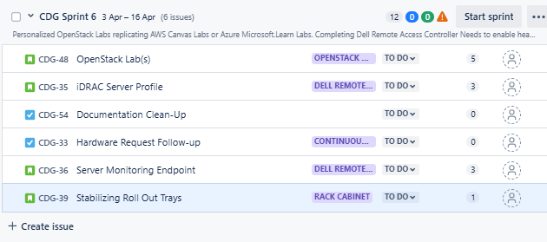

# Thoughts on Direction of Project

**Base OpenStack Deployment**

There are several routes for deployment that we are looking-that being kolla-ansible or OpenStack-ansible, charmed OpenStack, multi-node MicroStack, or a manual install.

However there are several issues that arise,

Kolla-ansible is the best route we have as the most popular deployment method and is currently being maintained and has frequent updates. We can not use this method as we are not allowed to access ansible through the CSU network. This issue will also be consistant with OpenStack-ansible.

Charmed-OpenStack by Canonical looks to be a good option however it’s last release was for 2023.2. It does not look to have had any updates since then and we are a little worrisome this may remain the case for the future. Multi-node Microstack, which was also created by Canonical, was updated to handle smaller production level environments in 2023. This is great news except there also looks to not be much surrounding this since 2023 either and the risk for something with many restrictions doesn’t make it a desirable option.

Puppet, chef, salt, and many other configuration and deployment management tools designed for OpenStack are older and unmaintained. They are even stated not to use on the OpenStack website. The primary option for us at this point is either manual or to wait for access to ansible.

With a manual approach, a blog I read of a team of several engineers with years up to decades of experience was not a good read for me personally. The author did a good job of driving home the fact that deployment and configurations was extensive and the addition of each individual service took many weeks and months for each. If we were to go the manual route, we would not finish in time and would need to hand over the rest of the work to the next up group that’ll come in. Only problem with this is that would they, A-want to continue with the painful task of the manual installation or B-should they be granted access to ansible at that point, wipe everything off and begin deployment with ansible. If I were them, I would choose the latter.

**What we will provide**

* Documentation of everything done so far and next steps

At a minimum, access to Desktop for DevStack would be nice to have. If we do get it then

* A DevStack Environment for others to run up and play around with the GUI or CLI
  + AWS style labs to do and learn about OpenStack
* Headless Servers
  + Ability to SSH to Ubuntu OS
  + Connect to iDRAC ip address and check state of the server

**Other access issues halting features**

We’d also like to get the physical server rack up but nothing has been completed as of yet for the hardware requests. This may also need to be handed to the next team sadly.

The DevStack environment would need to be moved from the servers once done this year, we’d also like to get access to the desktop but will patiently wait till we’re able to use it.

**Conclusion and Final Point**

Every feature of this project we’d like to work on becomes inaccessible due to network or hardware shortcomings. We will do our best to have something to hand off to the next team but each passing week it becomes more clearer that we may not be able to complete what we set out to do.